ATTENTION: CROSS COUNTRY COACHES

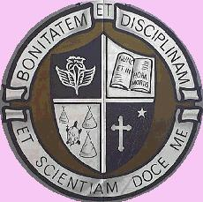

14th ANNUAL RAIDER OPEN
CROSS COUNTRY MEET
TUESDAY, SEPTEMBER 23, 2014
MIC MAC PARK

eMAIL ENTRIES TO: theresa_lukas@wecdsb.on.ca
by Friday, September 19th @ 4pm

ENTRY FEES: $3.00 per athlete up to a maximum of $100 per school

SCHEDULE: Midget Girls 2K 3:45 pm
Junior Girls 3K 4:05 pm
Senior Girls 4K 4:30 pm
Midget Boys 4K 5:00 pm
Junior Boys 5K 5:30 pm
Senior Boys 6K 6:00 pm

AWARDS: Raider Medals to top 3 individuals in each race
Goodies for Team Champions in each division

